# Alkem Smile User Manual

## Table of Contents

1. User Functionalities
   * Event Calendar & Registration
   * Volunteer Dashboard
   * Achievements & Certificates
   * Experience Sharing Hub
   * Guidelines & Information Pages

## User Functionalities

### 1. Event Calendar & Registration

* **Browse Events:** Users can view all upcoming and past events in a calendar/list format.
* **Event Details:** Click on an event to see its description, objectives, location, and FAQs.
* **Register for Events:** Users can register for available events directly from the Annual Event Calendar Section.
* **Registration Status:** See registration status (Nominated, Confirmed / Rejected, Attended/Not Attended)
* **Family/Friend Participation:** Option to add relations for group participation.

**Flow:**   
1. Navigate to Smile Website (through alkemites)  
2. Events Calendar Available at   
 a. Home Page (<https://www.alkemites.com/Smile/home>) scroll to Annual Volunteering Calendar Section

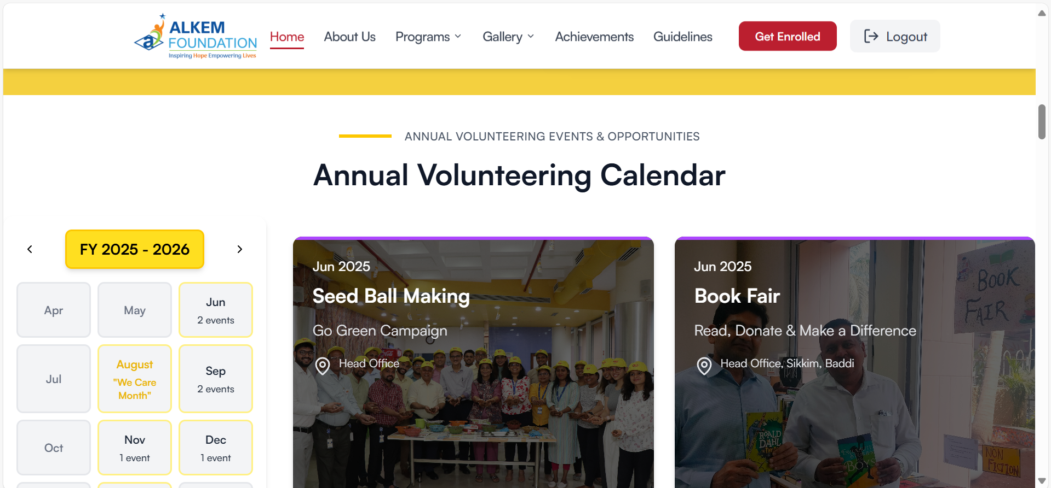

b. Volunteer Page (<https://www.alkemites.com/Smile/volunteer>) scroll to Annual Volunteering Calendar

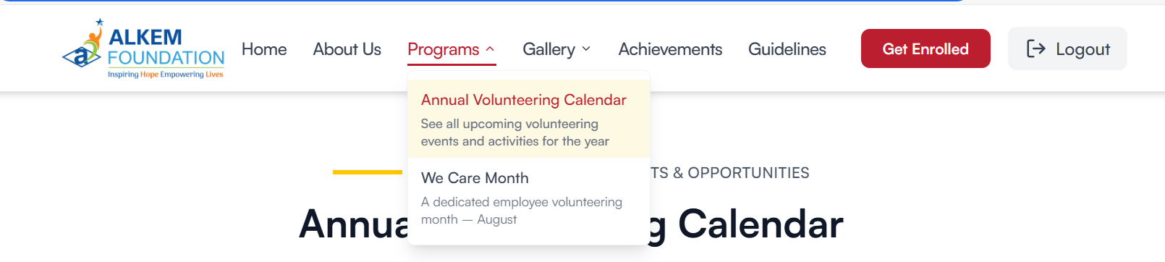

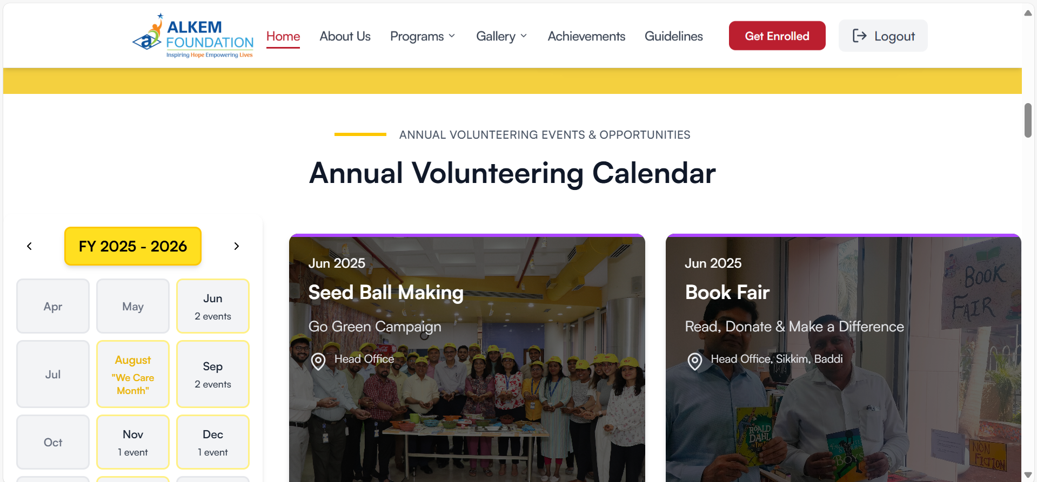

c. We care Month Page (<https://www.alkemites.com/Smile/we-care-month>) scroll to Calendar section

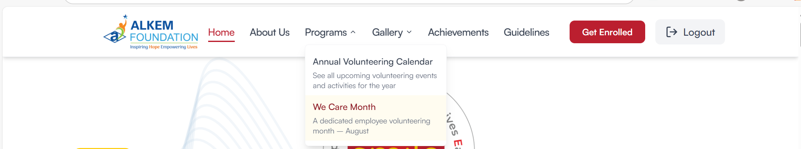

-------  
  
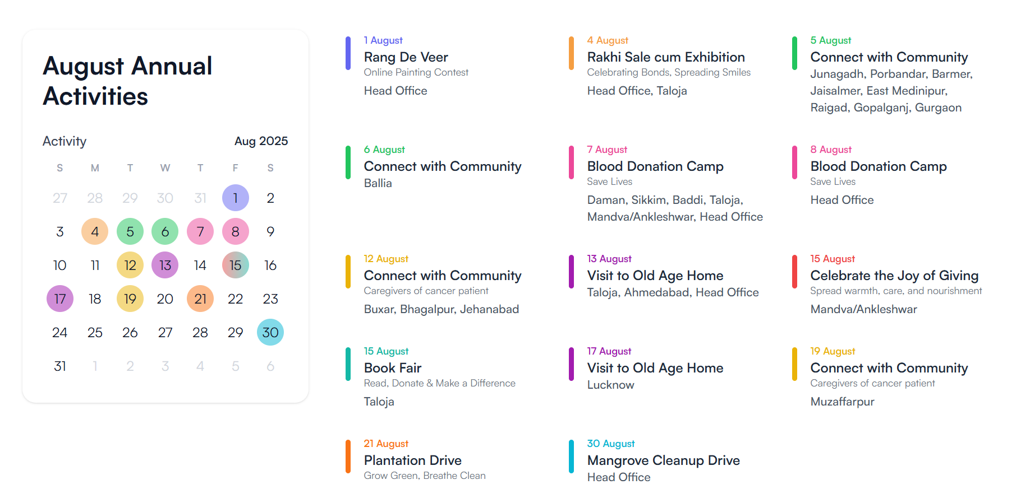

3. Browse events and select one.

a. Navigate through the calendar

- Month Wise / All events Filter: Click on a month’s tab or FY 2025 - 2026 to filter the events month wise and year wise accordingly.

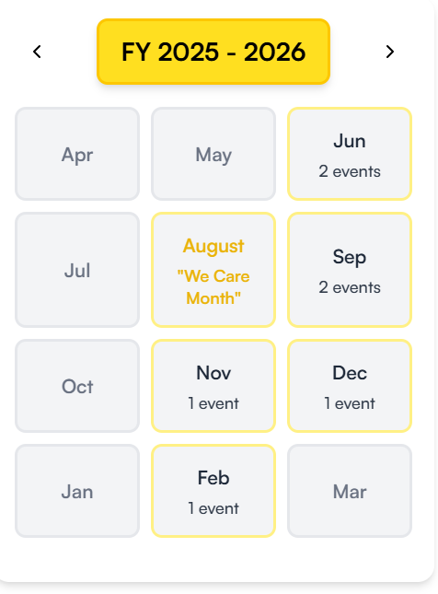

b. Selecting a Event

1. Hover and click over a Event Card:

a. In Annual Volunteer Calendar:

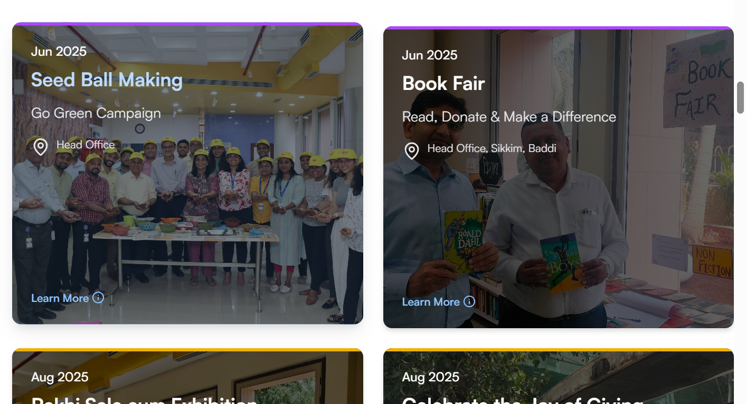

b. In August (“We care Month”) Page calendar:

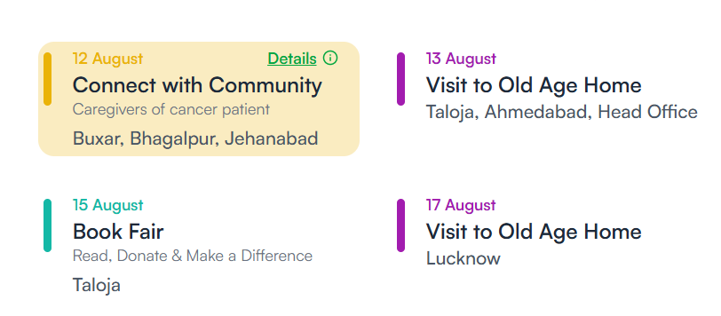

4. A overlay Popup will open with all the relevant details :

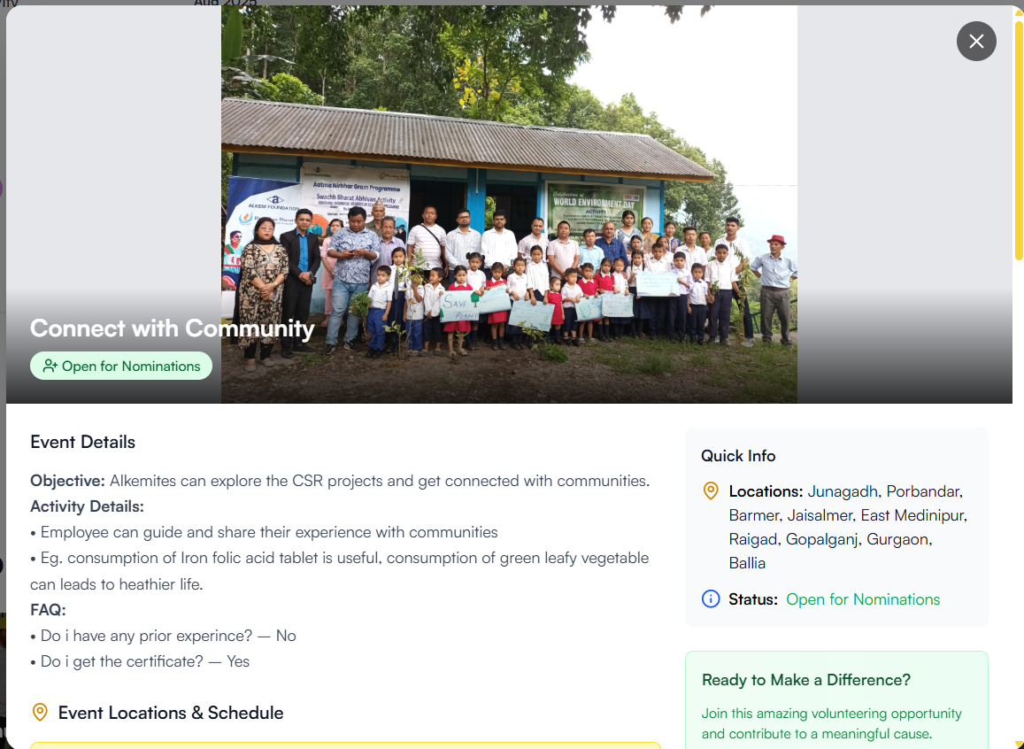

-------------------------

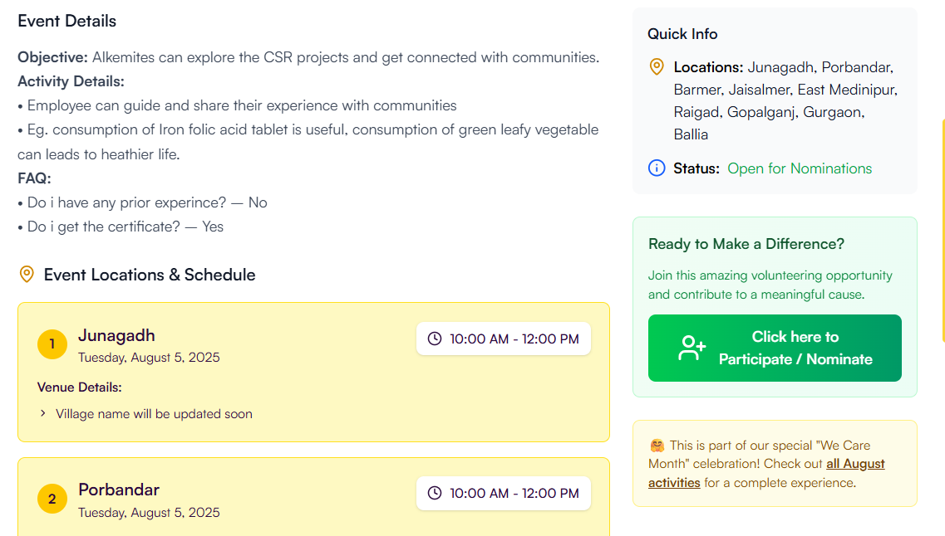

1. Click on “Click here to Participate/Nominate

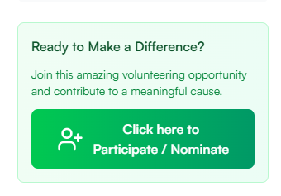

b. This will open the Participation/ Nomination Form  
  
  
  
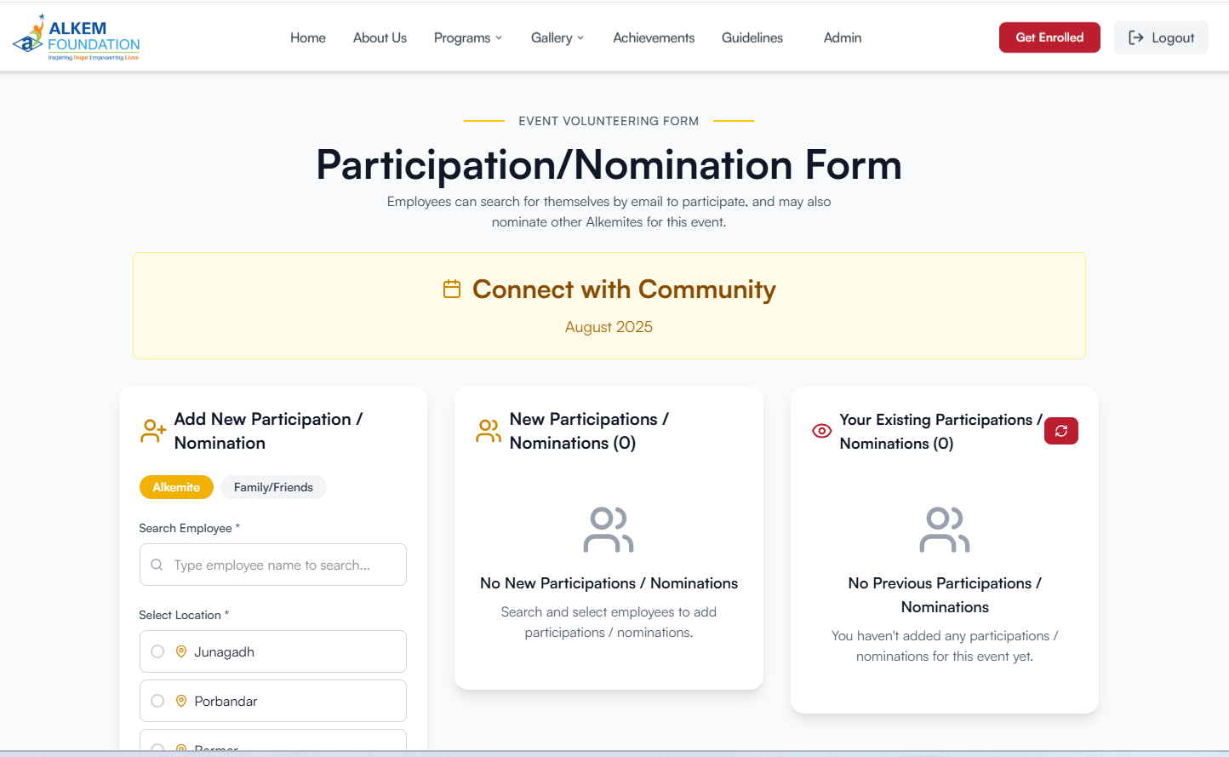

c. Add the nominations / participants from the left-most section , toggle between Alkemite and Family/Friends as required and fill in the required Details  
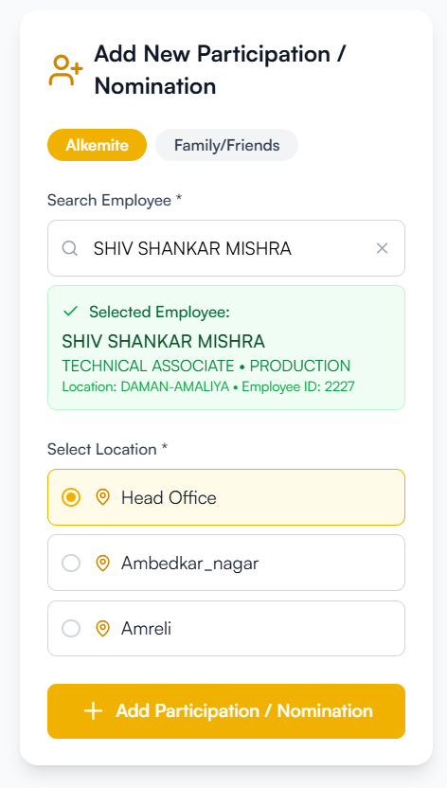 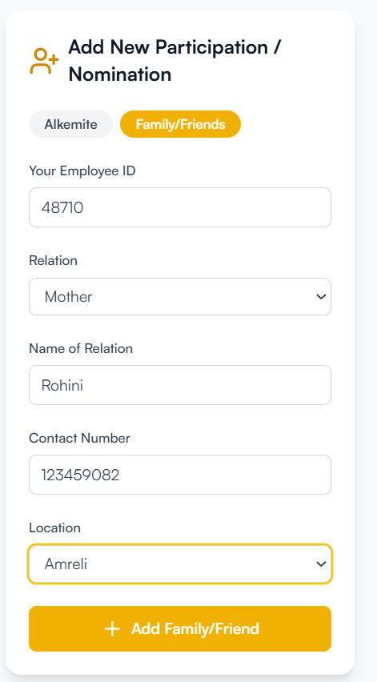

d. After adding individual nominees a summary of all the nominations you have added will be shown in the middle section, after confirming the selection click on submit to confirm sending the nominations

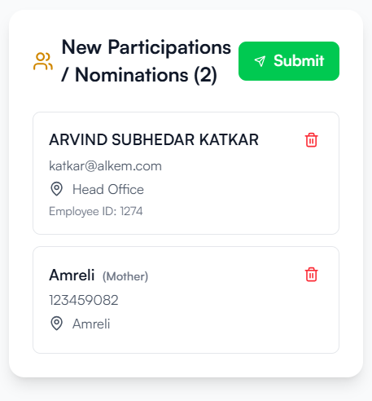  
  
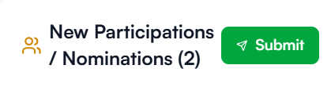

e. After submitting all the nominations, you have added now or before will be visible in the right most section, and all the Alkemites including you (If you have added yourself) will receive a mail in a short time about the confirmation that the nomination has been received.

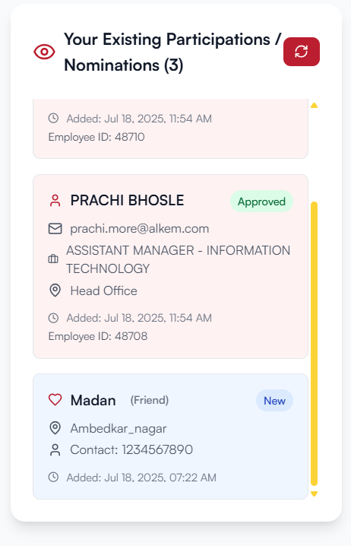

### 2. Achievements Page cum Volunteer Dashboard

* **My Events:** View all events the user has registered for or attended.
* **Attendance & Rating:** Mark attendance and rate completed events.
* **Download Certificates:** Download certificates for eligible events.
* **Status Tracking:** See event status (upcoming, attended, certificate available).

**Flow:**   
1. Go to “Achievements” (<https://www.alkemites.com/Smile/achievements>).  
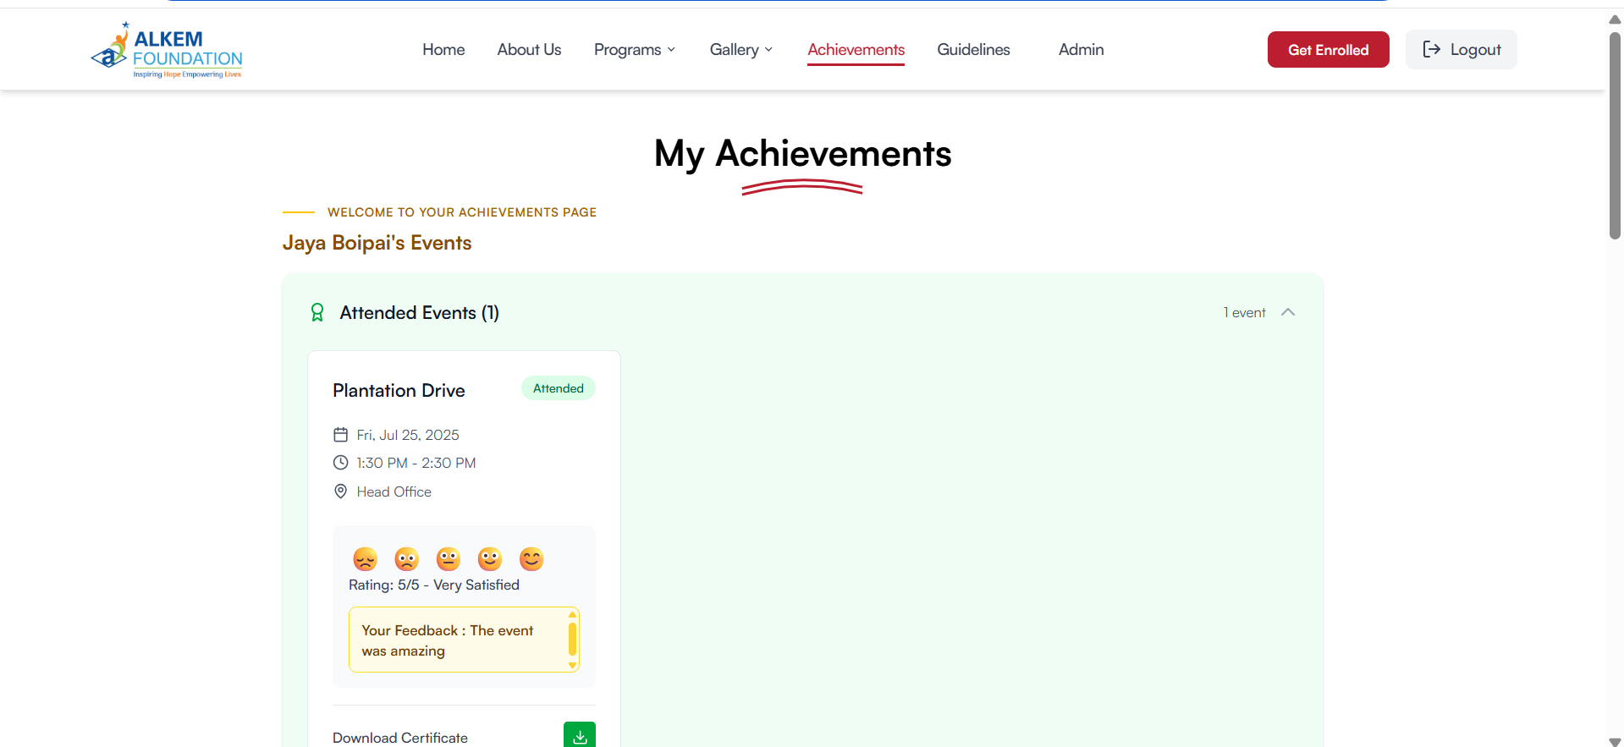

2. Here we can see 4 types of section:  
 a. Attended Events:

* Here you can rate and add feedback for the events you have attended (**Note:** You may also receive a email about the same for rating and giving feedback, if you have submitted through mail that data will be displayed in these cards)
* If the activity has a certificate available, use the download certificate button to get a digital copy of the certificate  
    
  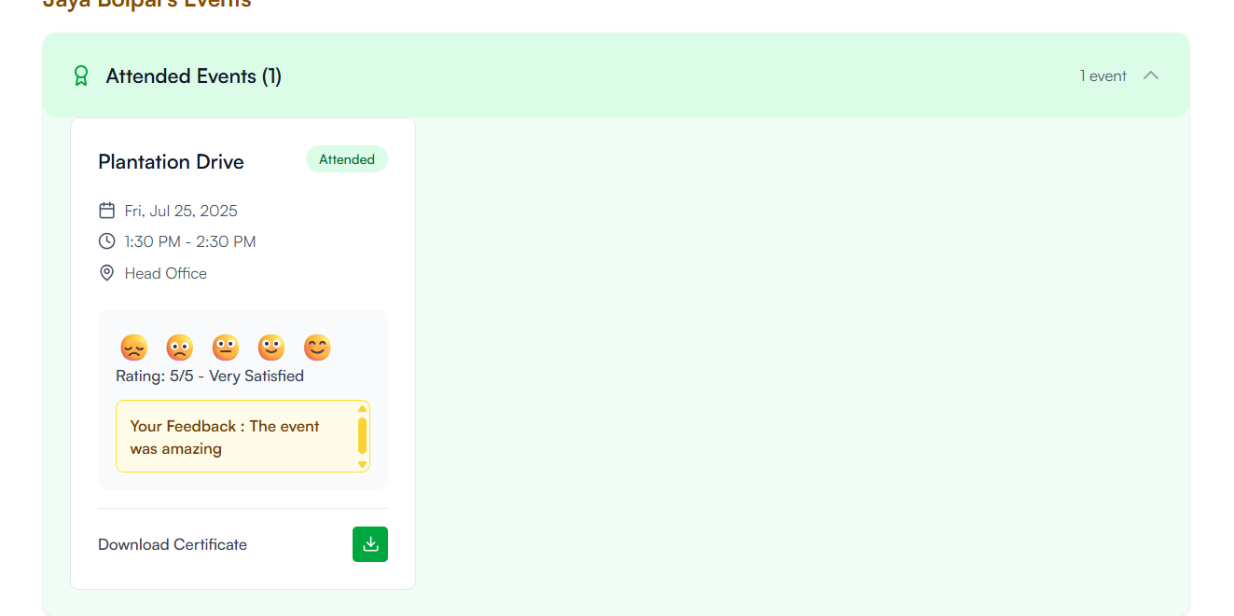

b. Upcoming Events:

* Here you can see the list of events you have been nominated for by yourself or by other  
  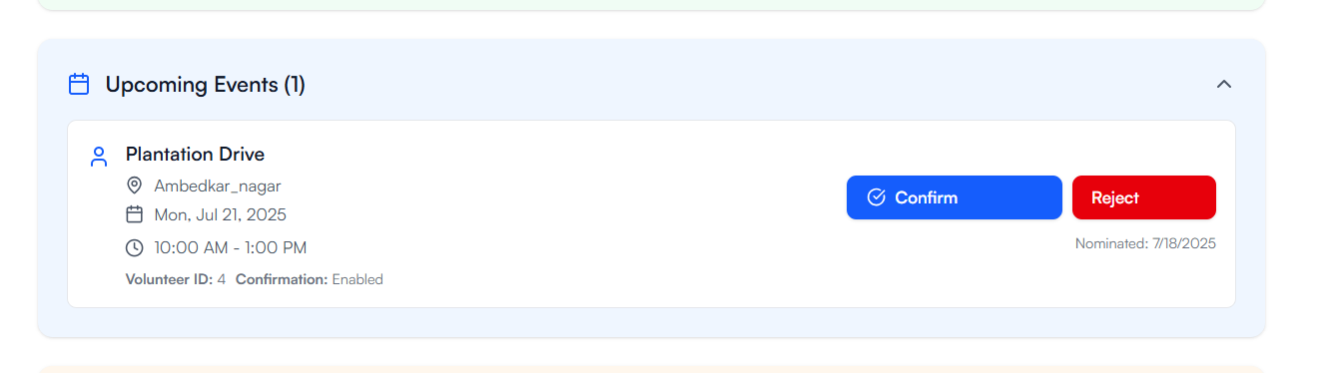  
  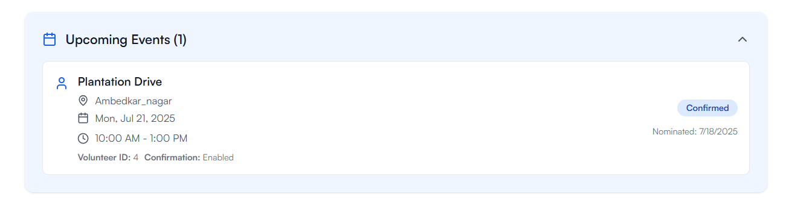
* If the event is confirmed (the event details are finalized) here you will have the option of Confirming or Rejecting your participation  
  (**Note:** You will receive a similar mail about confirmation if you have recorded your reply there it will be reflected over here)

c. View All events:  
 - Here you can see the list of events you have not attended, or you rejected the nomination  
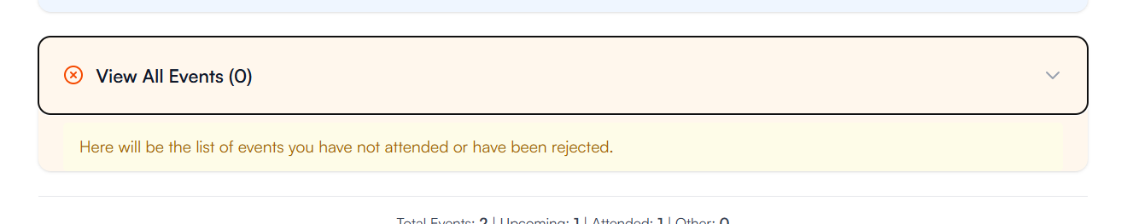

### 3. Experience Sharing Hub

* **Share Experience:** Submit text and images about volunteering experiences.
* **View Gallery:** Browse experiences in a grid.

**Flow:**   
1. Go to “Experience” page. (<https://www.alkemites.com/Smile/experience>)  
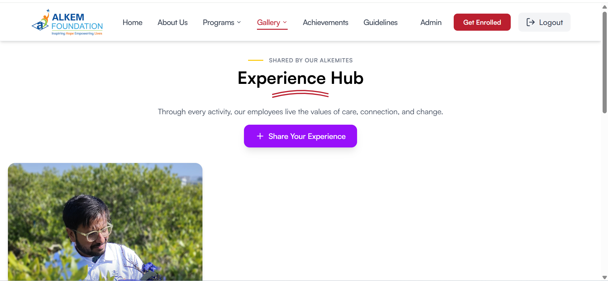  
  
2. Click on “Share Experience” button,

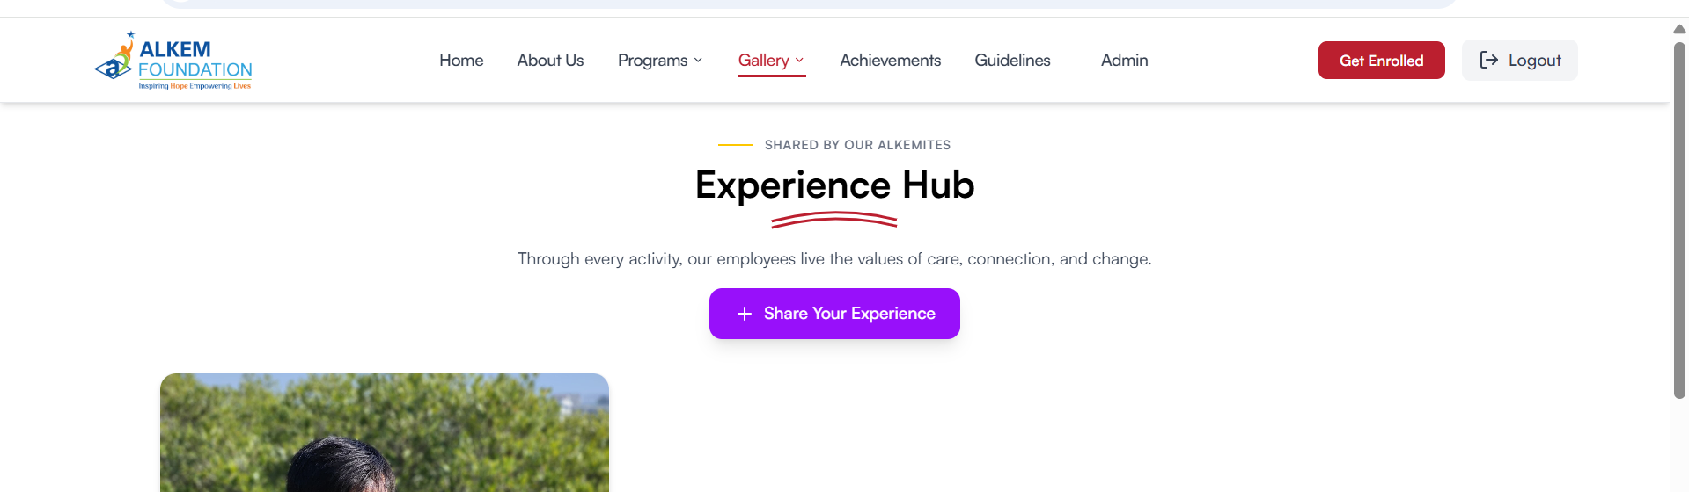  
  
3. Select one of your attended events, here you can submit and Photo with a short write up about your experience of the event which may later be shared on the website.  
  
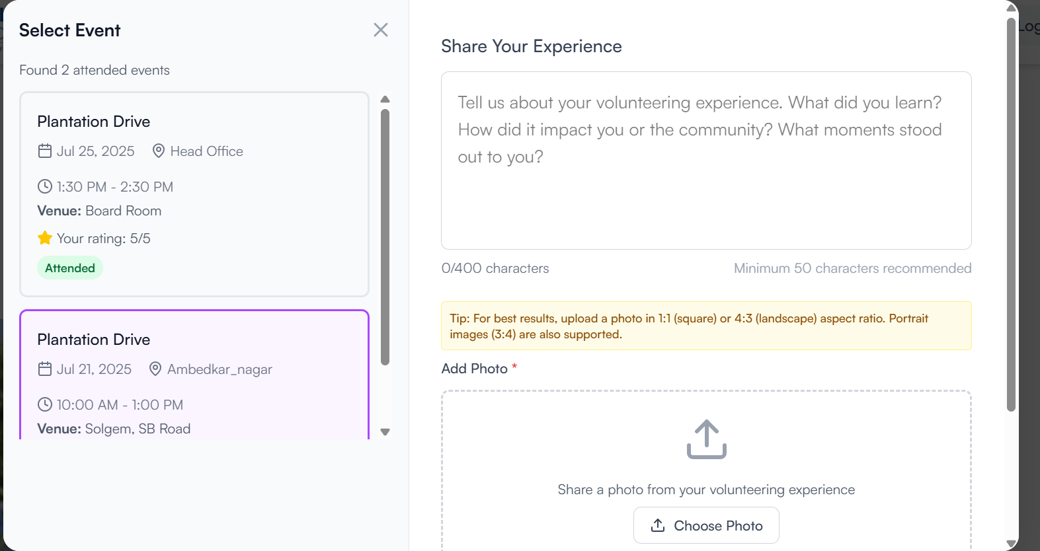  
  
  
(**Note:** Only one experience per event can be shared, also you may receive a mail about the same if you have filled it there your response will be reflected here)  
  
4. Explore the experience page all the submissions in the grid, click on an experience you would like to read to get more details about the experience submission.   
  
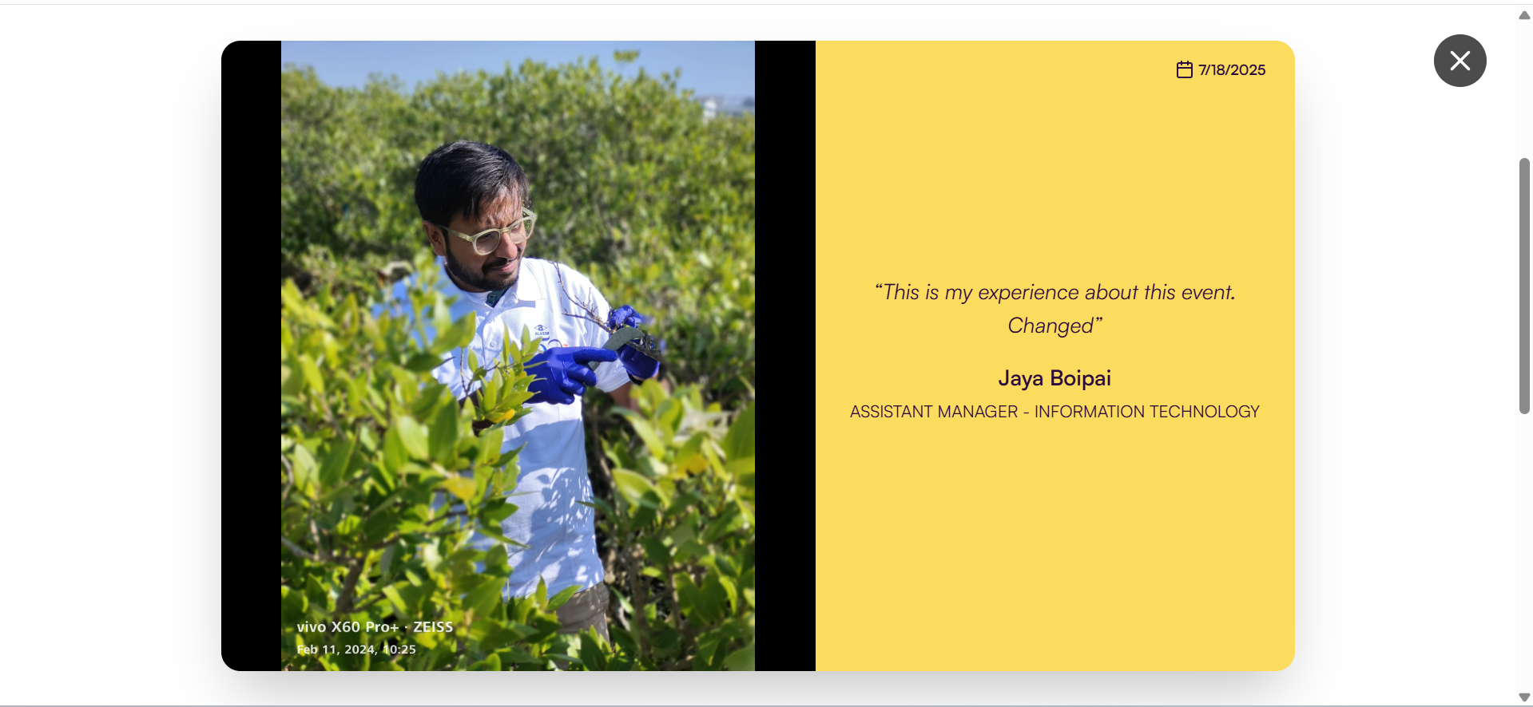

### 5. Guidelines & Information Pages

* **Guidelines:** Access volunteering guidelines, FAQs, and instructions. (<https://www.alkemites.com/Smile/guidelines>)  
  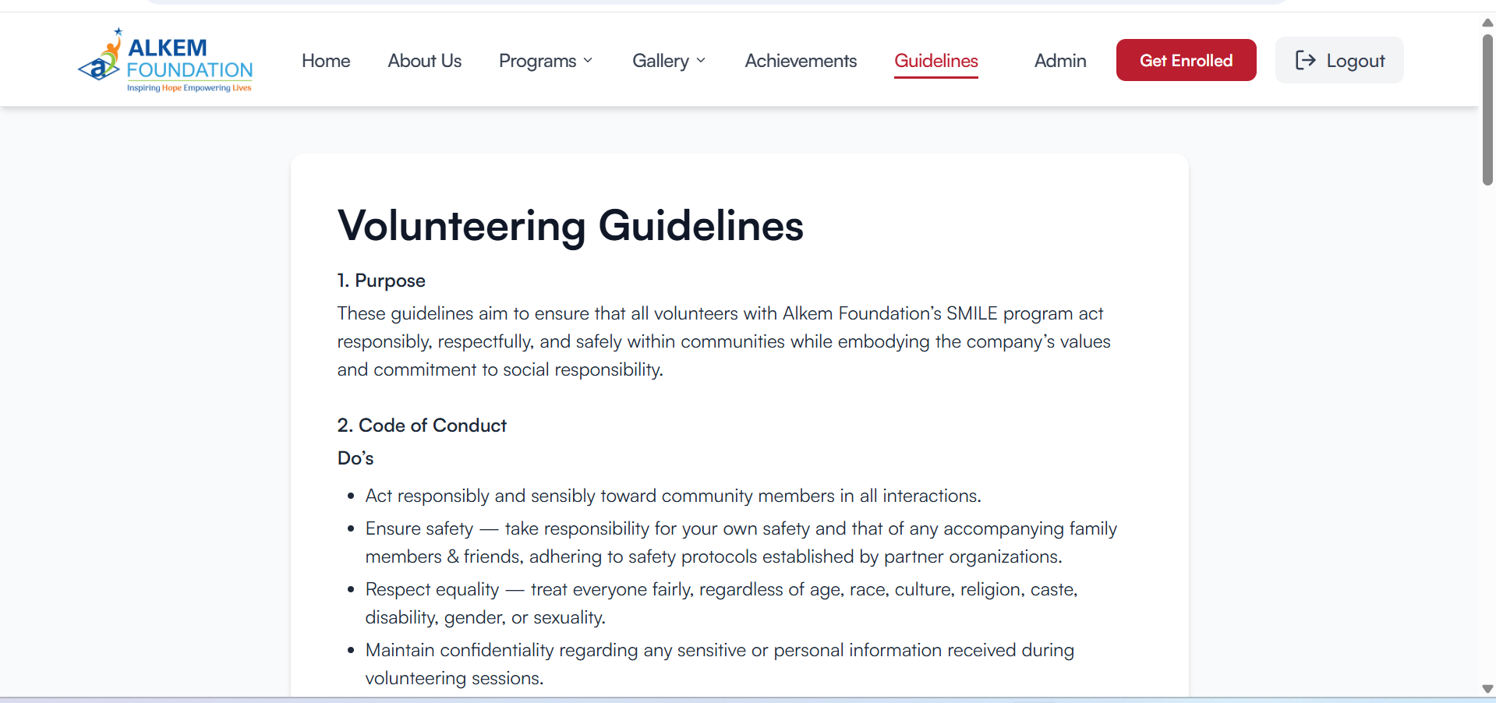
* **Contact:** View contact information for support.
  + **At footer :**   
    